LOCAL COLLEGE DATABASE SYSTEM
Jeremy Isaacs
Introduction to Relational Database Management Systems
Dr. Progress Mtshali, Ph.D.
Strayer University
October 14, 2016

LOCAL COLLEGE DATABASE SYSTEM
Purpose of the Database
We provide the description of the database system for the local college that supports the college administration to keep the track record of the students, courses offered and they take admission to as well as maintain the complete data of the instructors(faculty) teaching in the particular courses. The database comprises of the data records about the new and existing the new and existing students, faculty or instructor offers teaching into the courses offered by the local college with some departments or classes respectively. The purpose of a database is to keep track of things. This information is achieved by storing data in tables. Each table has rows and columns, much like an Excel spreadsheet. A database usually has multiple tables to keep track of information by related things. For example, we might have a STUDENT table to keep track of students and a FACULTY table to keep track of the instructor data we administer. Each row in each table holds data about a particular instance, i.e., one student and instructor. The database also stores a link between all of the tables, so that information can be tracked like ID, courses, and department. (Chopra, 2010)
Entities and their attributes of the college database (E-R diagram of the College Database)
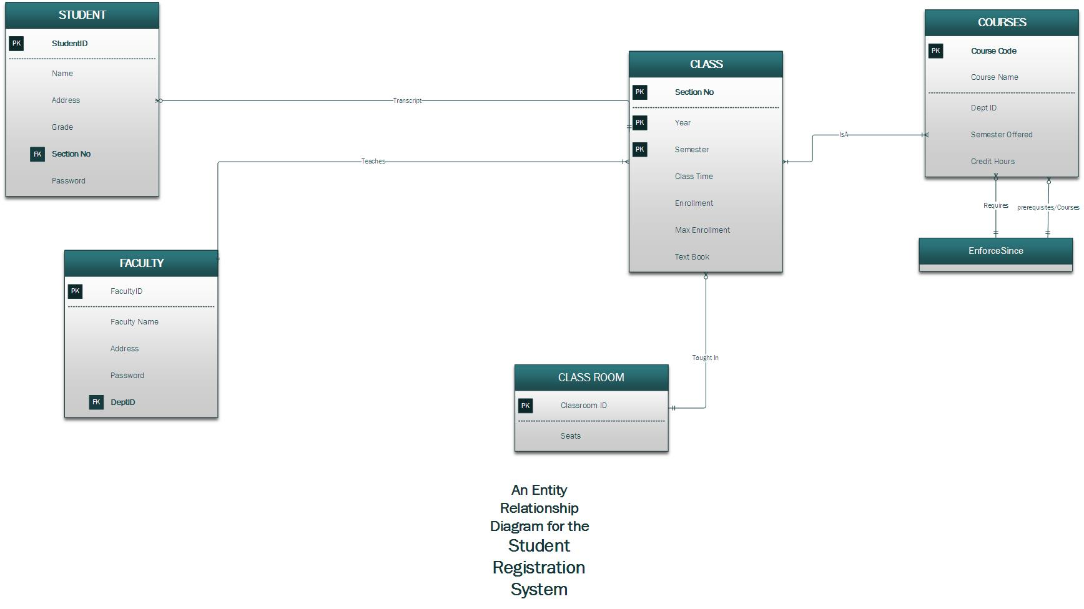
Fig. 1 an Entity-Relationship Diagram for a Local College Database
Source: (Chopra, 2010)
Entities of the database are Student, Faculty, Class, Courses, and Classroom.
Attributes:
- Student: StudentID (Primary), Name, Address, Grade, Section No, Password.
- Faculty: FacultyId (Primary), Faculty Name, Address, Password, DeptId.
- Courses: Course Name, Id (Primary), DeptId (foreign key), Semester offered, credit hours.
Business rules that could impact the structure of the database
Conceptual model and Physical Model of the database
Conceptual Model
The conceptual model of the database of the local college must include the information that identifies the highest level associations amid the different entities of the database system. The conceptual model comprises of these data features:
- It comprises the significant database entities and the respective relationships between them. For example, entity Student related to the entity Course as the student whether new or existing in the college records has a one-to-one (one-to-many) relationship. Each of the students must take admission in one course into a particular department. Whereas Faculty (Instructor) has a relationship with Course and Class entities as each of the instructor must study at least a single course in the particular department of the local college.
- The most important entities that show in the conceptual model are student, faculty, and course with their respective attributes.
- In this view or model, primary keys are not detailed explicitly in the database e.g. course Id, student Id, etc.
- No attributes of any database entity are illustrated in the conceptual model.
Physical Model
The physical model of the local college database has several entities and related attributes. The model has information about the entities and relationships amid them. The model shows the information that a local college comprises of some departments. Each department has numerous courses. Some class marks up every offered course. Students register for a specific course and yield course offered in particular class concerning the end of the course. Each class has faculty each having a particular course taught by a faculty or instructor from the suitable department. Also, each faculty teaches a group of students. The physical model displays all table structures, comprising column data type, column name, primary key, column constraints, foreign key, in addition to relationships amid tables (Malcher, 2010).

Works Cited
Chopra, R. (2010). Database Management System (DBMS)A Practical Approach. S.Chand Publications.
Malcher, M. (2010). Oracle Database Administration for Microsoft SQL Server DBAs. McGraw-Hill Professional.
Coronel, C. (2017). Database Systems, Design, Implementation, and Management
Cengage Learning

.

